Expression System
The production of a protein requires an expression system. There are two types of expression systems, prokaryotic and eukaryotic expression system. Each of them has its own advantages and drawbacks which can be taken into consideration while constructing an expression system. However, there is no such expression system which can be considered universal for the heterologous protein production.
Prokaryotic Expression System
- The specificity of the promoter of an RNA polymerase, in the case of prokaryotes, is mediated by sigma factor.
- E. coli is the widely used prokaryotic expression system.
- It expresses high levels of the protein.
- The E. coli strains are manipulated genetically for the production of recombinant protein so that they are rendered safe for large-scale experiments and
- fermentation.
- The purification of the protein has become easier since recombinant-fusion proteins can be purified by affinity chromatography, for example glutathione-S-transferase and maltose-binding fusion proteins.
Fusion Proteins
- Proteins expressed by the expression vectors may be expressed as native polypeptides or fusion proteins.
- Fusion proteins facilitate the purification and analysis of the protein.
- Fusion proteins also referred to as the chimeric or hybrid proteins, are the end product of the coding sequence of different genes which are cloned together and yield single polypeptide sequence after translation.
- They protect the gene of interest from the proteases present in the host cell.
- The cloned gene proteins are resistant to degradation when they are present in combination with the fusion protein. When these proteins are expressed as separate entities, they are vulnerable to degradation and undergo proteolysis.
- A fusion vector system has a target gene inserted into the coding sequence of the cloned host gene.
- At the level of DNA, fusion proteins are constructed by ligating coding sequence of different genes. For this, the knowledge regarding the nucleotide sequence of the coding genes or segments is a prerequisite for ensuring that ligation gives rise to the correct reading frame.
Regardless of the advancements and improvements occurring, in the prokaryotic expression system, there are still many difficulties associated and challenges posed by the production of protein from the cloned foreign genes. These kinds of challenges can be grouped together into 2 categories:
- Challenges because of the nature of the sequence of the foreign gene
- The presence of introns in foreign genes.
- The presence of the termination signals.
- The genes in prokaryotic as well as eukaryotic expression systems observe a defined utilization of synonymous codons. This is referred to as codon bias. Since the codons are degenerate, there is a bias for two or more codons. In some cases, different genes prefer only certain codons. These specific codons are used frequently regardless of the abundance of the protein taken into consideration, for example, CCG is a widely accepted codon for proline. The genes with high levels of expression exhibit codon bias towards certain codons compared to the ones which are expressed at low levels. The frequency of utilization of synonymous codons reflects the degree of abundance of their corresponding tRNAs.
- All these observations transport us to the result that genes with codons which are hardly used by the E. coli expression system may not be efficiently expressed in the E. coli.
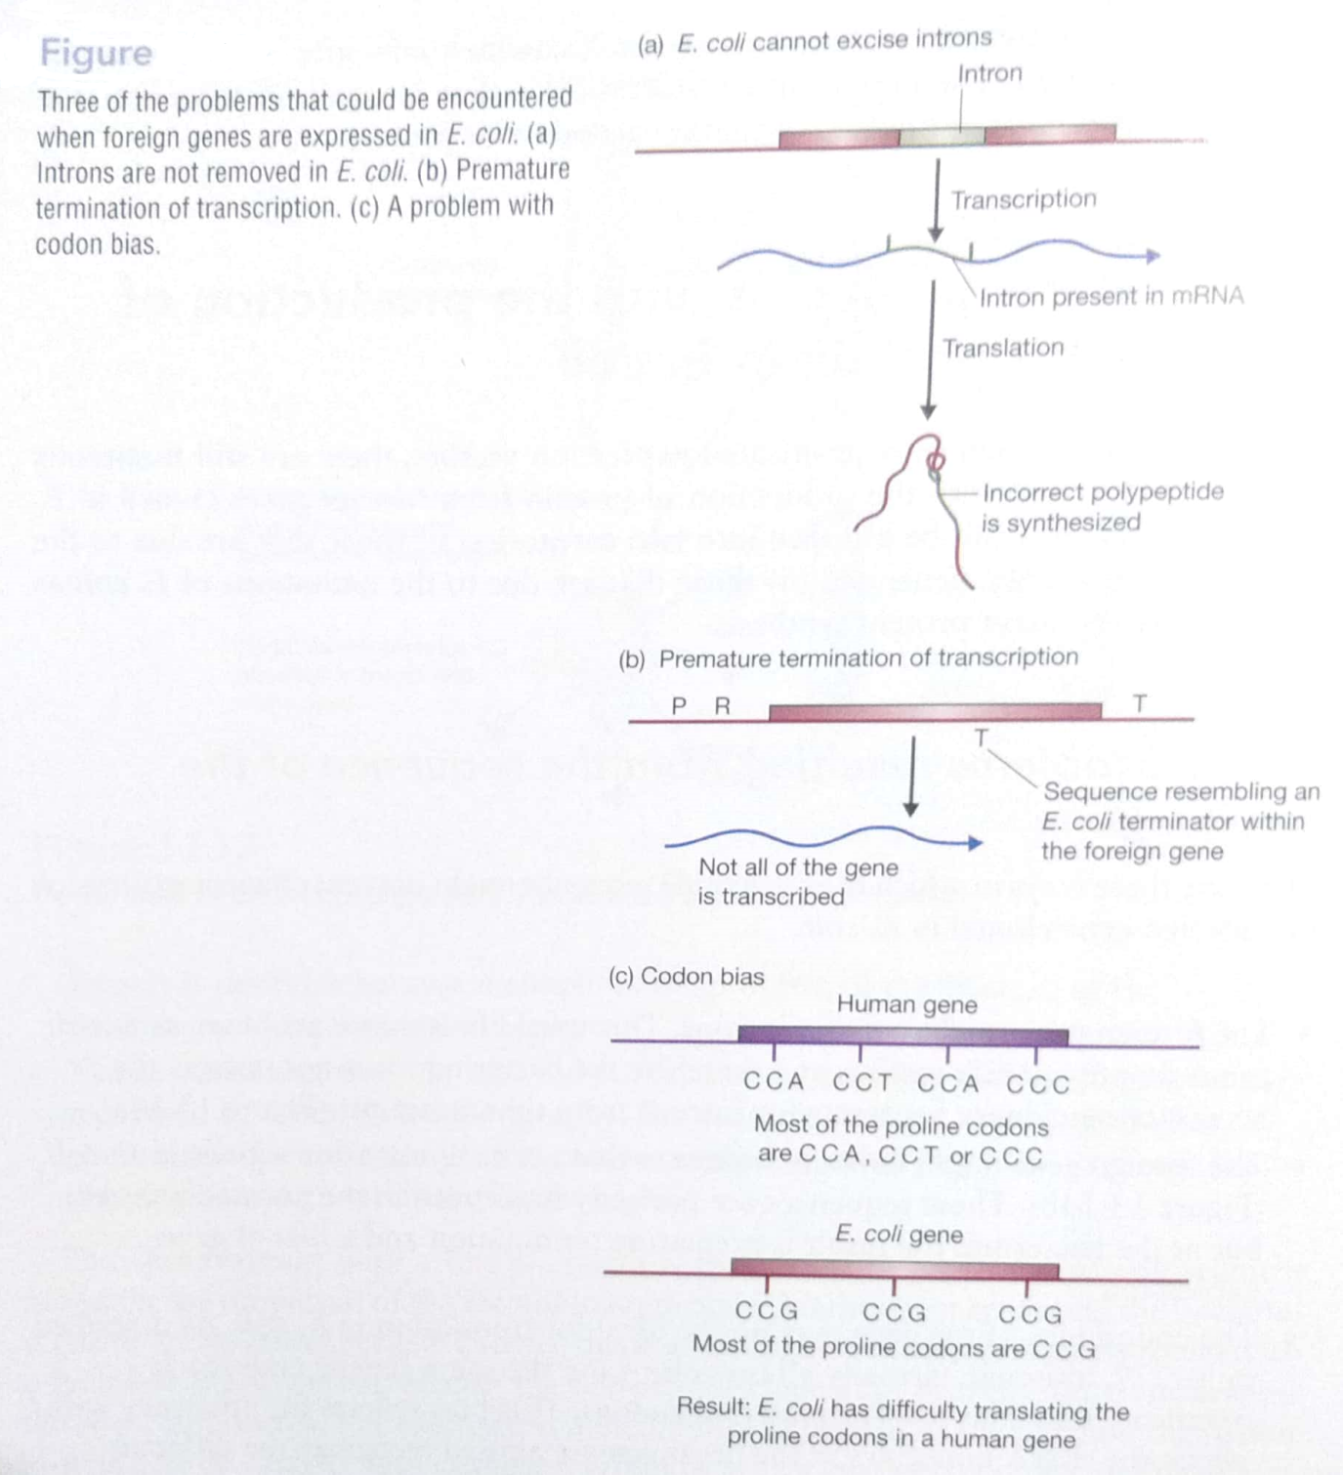
2. Challenges due to the prokaryotic host, E. coli
- The processing of proteins poses one challenge. Prokaryotes carry out post-translational modifications of their proteins in a rather different way than eukaryotes do. This, in turn, can affect a protein’s stability, activity, and response to antibiotics.
- The folding of proteins renders yet another challenge. The protein products of eukaryotic foreign cloned genes may fold incorrectly in the prokaryotic expression system. This may lead to the formation of insoluble aggregates, also known as inclusion bodies, which are not recovered as functional proteins. The foreign proteins may fold incorrectly either because of exposure of the hydrophobic residues, which are generally present inside the core of the protein or because of lack of interactions which occur in the normal environment or inappropriate post-translational modifications.

